Z9.

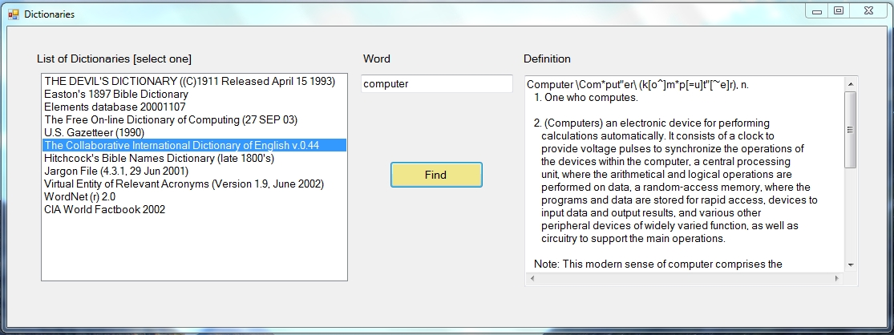

adres: http://services.aonaware.com/DictService/DictService.asmx

obiekt: com.aonaware.services.DictService

