Z10P.

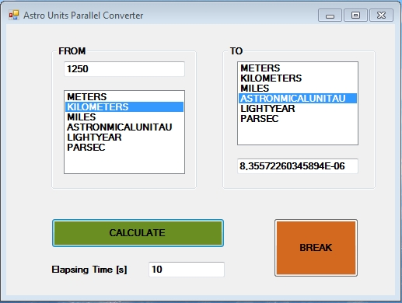

http://www.webservicex.net/Astronomical.asmx?WSDL

