AmiRNA Designer - new method of artificial miRNA design.

Agnieszka Mickiewicz^{a*}, Agnieszka Rybarczyk^{a,b*}, Joanna Sarzynskaª, Marek Figlerowicz^{a,b}, Jacek Blazewicz^{a,b}

ªInstitute of Bioorganic Chemistry, Polish Academy of Sciences, Z. Noskowskiego 12/14, 61 704 Poznan, Poland.
^{b}Institute of Computing Science, Poznan University of Technology, ul. Piotrowo 2, 60-965 Poznan, Poland

Author for correspondence: Agnieszka Rybarczyk, Institute of Computing Science, Poznan University of Technology, ul. Piotrowo 2, 60-965 Poznan, Poland; phones: (+48 61) 879-07-90 ex.148, fax: (+48 61) 877-15-25, email: arybarczyk@cs.put.poznan.pl

*Contributed equally to this work

ABSTRACT
MicroRNAs (miRNAs) are small non-coding RNAs that have been found in most of the eukaryotic organisms. They are involved in regulation of gene expression at the post-transcriptional level in a sequence specific manner. MiRNAs are produced from their precursors by Dicer-dependent small RNA biogenesis pathway. An involvement of miRNAs in a wide range of biological processes make them excellent candidates for studying gene function or for therapeutic applications. For this purpose, different RNA based gene silencing techniques have been developed. Artificially transformed miRNAs (amiRNAs) to target one or several genes of interest represent one of such techniques being a potential tool in functional genomics.
Here, we present a new approach for amiRNA design , implemented as AmiRNA Designer software. Our method is based on the thermodynamic analysis of the native miRNA/miRNA* and miRNA/target duplexes. In contrast to available automated tools, our program allows the user to perform analysis of natural miRNAs for the organism of interest and to create customized constraints for the design stage. It provides also filtering of the amiRNA candidates for the potential off-targets.
AmiRNA Designer is freely available at http://www.cs.put.poznan.pl/arybarczyk/AmiRNA/.

Keywords: artificial miRNA, RNAi, gene regulation, sequence specific, thermodynamic profiles.

INTRODUCTION
RNA interference (RNAi) is a widespread mechanism responsible for regulation of gene expression in Eukaryotes. One of the key elements of the RNAi machinery are small regulatory RNAs (srRNAs) which serve as 20-30 nt probes targeting multienzymatic protein complexes to specific transcripts or genes (Obernosterer et al., 2006). It has been suggested that 60-90% of eukaryotic genes are regulated by srRNA (Friedman et al., 2009). srRNAs are involved in gene regulation at both transcriptional and post-transcriptional level. Various classes of srRNAs differ in mode of biogenesis, precursor structure and in their function in gene regulation (Kim, 2005a, 2005b, Blazewicz et. al., 2011, Nowacka et. al., 2011, Szostak et. al., 2014). Among them, microRNAs (miRNAs) and small interfering RNAs (siRNAs) are found to be the most important for post-transcriptional gene silencing.
The miRNAs are endogenous in both plants and animals and originate from intergenic regions or introns, as primary precursors (pri-miRNAs) transcribed by RNA polymerase II (Lee et al., 2004, Xie et al., 2005). These precursors fold in stem-loop structures that contain a ca. 21-nucleotide (nt) miRNA in the 5′ and/or 3′ arm of the stem. However, there are differences both in the miRNA biogenesis and the structure of the precursor in plants and animals (Bologna et al., 2013). Animal miRNA precursors are ca. 80 nt long and two different proteins, Drosha and Dicer, carry out the cleavage reaction. Drosha in the first nuclear step releases pre-miRNA (Han et al., 2006) and then Dicer yields miRNA/miRNA* duplex in the cytoplasm. Plant miRNA precursors are often significantly longer, up to over 600 nt, display structural diversity and are cleaved in the nucleus by Dicer-like 1 protein (DCL1) (Kurihara and Watanabe, 2004) by several mechanisms, depending on the processing direction and the number of the cuts, eventually generating a ca. 21-nt miRNA/miRNA* duplex (Bologna et al., 2013). Next, both in animals and plants, the miRNA (guide strand) is preferentially loaded onto the Argonaute protein (AGO) component of the RNA-induced silencing complex (RISC) while the miRNA* (passenger strand) is destroyed. The preferential loading of the guide strand is determined by thermodynamic asymmetry along the miRNA/miRNA* duplex (Eamens et al., 2009). The characteristic, thermodynamically unstable 5′ end of the miRNA strand allows this molecule to be loaded onto the RISC. The miRNA then directs the cleavage of messenger RNA (mRNA) through the AGO in the RISC or represses translation of the transcript (Valencia-Sanchez et al., 2006). Although the RNAi pathway is universal, there are differences in mode of its function in animals and plants. Plant miRNAs usually display perfect or near-perfect pairing with their mRNA target sites (Axtell et al., 2011). Animal miRNAs are less complementary to their target sites. They harbor “seed” region: 2-8 nucleotides of the 5′ ends complementary to ca. 7 nt of the target (Bartel, 2009). It was thought that the complementarity level is connected with the mechanism of inducing gene repression by miRNA. The most complement miRNAs were suggested to act through degradation of their target transcripts whereas the less paired - to repress translation. While this is true in the case of animal models, there is no obvious evidence for the same correlation in plants (Brodersen and Voinnet, 2009), and the mechanism remains still unclear. Another difference is in the location of miRNA target sites. In animals, miRNA target sites are located mostly within 3’ untranslated regions (3’ UTR) whereas in plants miRNAs bind both to the coding and untranslated regions. In plants miRNAs regulate mostly growth and developmental processes (Mallory and Vaucheret, 2004), and are involved in various stress responses (reviewed in Sunkar et al., 2012). In animals, miRNAs are involved in proper functioning of every cell (Chekulaeva and Filipowicz, 2009), and their dysfunctions are associated with various diseases (reviewed in Meola et al., 2009).
The second important class of molecules that trigger RNAi mechanism in plants and some animals are siRNAs (Carthew and Sontheimer, 2009). They originate from invading viruses, transgene inverted repeats, centromeres, transposons, and other repetitive sequences and they silence these sequences. The long double-stranded RNA (dsRNA) derived from a transgene construct is a common entry transcript in the siRNA pathway. It is diced sequentially into short (21–24 bp) fragments by Dicer2 (or Dicer1) in case of animals or Dicer-like 2 – 4 in plants. The siRNA is thought to be an RNA-based immune mechanism to fight off nucleic acid invaders or to maintain genome stability.
As the siRNA-based technology seems to be easy to implement, there were several application based on long dsRNA to regulate a specific gene of interest (Chau and Lee, 2007). However, the generation of a pool of multiple short RNA may result in unspecific silencing (off-target effect), which has been especially carefully studied for animals (Petri and Meister, 2013). In contrast, the biogenesis of miRNA is a highly precise mechanism that results in arising of a homogeneous pool of short regulatory RNAs. For this reasons, the idea of miRNA-based method of both endo- and exogenous regulation has been developed. The main concept of the artificial miRNA (amiRNA) is to design a 21 nt RNA sequence that is able to regulate the target gene expression. This sequence is introduced into the miRNA precursor backbone to replace the native miRNA. Such structure forms a fold similar to natural miRNA precursor structure and will be processed in the miRNA biogenesis, despite the absence of the amiRNA sequence in the wild type organism and therefore it is called “artificial”. Artificial miRNA seems to be a promising technique for both functional genetic studies and plant antiviral protection or plant genetic improvements.
For the time being, there are several bioinformatics tools capable of designing amiRNA for specific organism or a group of organisms. As the biogenesis and the mode of action of animal and plant miRNAs are significantly different, separate tools have been developed for amiRNA design in animal and plant species. One of the mostly used tools dedicated to plants is web-based software Web MicroRNA Designer (WMD3) (Ossowski et al., 2008, Schwab et al., 2006). Recently, a novel web-based tool for automated design of the amiRNA and synthetic trans-acting siRNAs sequences has been developed (Carbonell et al., 2014). Another tools such as miR-Synth (Laganà et al., 2014), AmiRzyn (Baby et al., 2012) are designed for human amiRNA prediction only. Recent biological study of amiRNA designed using WMD3 software has revealed that the rules for creating effective amiRNA are not yet fully understood (Li et al., 2013). Some amiRNA sequences determined by the WMD3 and designated as recommended have shown less silencing efficiency than those less recommended, which have reached the efficiency of 90%. Most available tools are based on sequence complementarity and other parameters such as calculation of the overall hybridization free energy of the miRNA/target duplex or/and the miRNA precursor secondary structure (Yu et al., 2014). However, statistical analysis of the thermodynamic profiles of published miRNA molecules has revealed that the thermodynamic properties play a crucial role in determining the functionality of these molecules. It has been shown, that functional miRNAs exhibit distinguishing thermodynamic characteristics, different than in non-functional miRNAs (Khvorova et al., 2003, Krol et al., 2004).
In this work we present a new method to design plant amiRNA. Our method takes into consideration free energy decomposition of known miRNA/miRNA* and miRNA/target duplexes. On this basis, the thermodynamic profiles are generated, to which the free energy decomposition for the newly designed corresponding duplexes is compared.
Here, using our AmiRNA Designer, we generated a thermodynamic profile for miRNA/target and miRNA/miRNA* for Arabidopsis thaliana. Based on the obtained data we designed two independent sets of amiRNA candidates to silence two exemplary A. thaliana genes. The designed sequences of amiRNA and amiRNA* were analyzed with our Perl scripts for the off-target effect.
The AmiRNA Designer provides a flexible tool to semi-automated design of amiRNA for the organism of interest. The user can apply either pre-defined parameters, established based on the provided thermodynamic profiles for A. thaliana or to generate new profiles for their own set of miRNAs and to create customized constrains that can be used during designing of amiRNA.

MATERIALS AND METHODS

Data sources
Sequences for miRNA precursors were downloaded from miRBase rel18. (Griffiths-Jones et al., 2008) (truncated to an organism of interest – A. thaliana – in our case). Sequences of miRNA and their targets were taken from the ASRP database (Gustafson et al., 2005). For the off-target analysis we used a file from PlantGDB (Dong et al., 2004, Duvick et al., 2008) as a source of all expressed genes. Detailed information about the input data formats are provided in Software Manual (http://www.cs.put.poznan.pl/arybarczyk/AmiRNA/).
The target gene sequences were downloaded from TAIR database (http://www.arabidopsis.org/).

RNA secondary structure prediction
To predict the RNA secondary structure and obtain the free energy (∆G – expressed in kcal/mole) decomposition of generated structures, we applied the UNAfold software package (Markham and Zuker, 2008). UNAFold version 3.8 was used with the following parameters: energy rules set to RNA(2.3) (Walter et al., 1994) and temperature fixed to 22ºC. Calculations for miRNA/target duplexes and miRNA precursors were performed using the following UNAFold scripts: hybrid-2s.pl (for duplexes) and hybrid-ss-2s.pl (for single sequences).

RNA thermodynamic profiling
Based on the free energy decomposition obtained from the secondary structure prediction, the following thermodynamic profiles were calculated (in the same manner): miRNA/target and miRNA/miRNA*.
The profiles were generated by assigning ΔG values to each nucleotide position in the miRNA sequence. The ΔG values were assigned based on the free energy decomposition provided by UNAfold for each of the analysed duplexes (details of the profile generation are in Supplementary Materials). Next, statistical analysis of the thermodynamic data obtained for each miRNA was performed. The final profile provides free energy distribution associated with each miRNA position in miRNA/target and miRNA/miRNA* duplexes, respectively. The thermodynamic profiles are automatically created by AmiRNA Designer for the input data provided by user and the results are saved as a statistic sheet in the csv format for each profile respectively.

Relaxation rules
During amiRNA design stage, it is checked whether the changes of the ΔG values at the individual positions of the amiRNA candidate show the same overall trend as the medians in miRNA/target thermodynamic profile.
If a median value at a given position “i” in the profile is higher than at position “i-1”, the actual value of the ΔG at the corresponding position “i” in amiRNA should be greater or equal to the median value at position “i-1”in the miRNA/target profile. The amiRNA sequences that do not satisfy this condition at any position are immediately rejected. Otherwise, if a median value at a given position “i” in the miRNA/target profile is lower than at position “i-1”, the value of the ΔG at the corresponding position in amiRNA should be lower or equal to the median value at position “i-1”, in the profile. If a ΔG value at a given position in amiRNA is lower than required (the binding is too strong compared to the profile), the nucleotide at this position can be substituted. We developed the term “relaxation” to describe this situation. Relaxation allows introducing non-canonical GU pairs, which are often found in RNA secondary structures. Exchange of the canonical base pair to the GU pair destabilizes the RNA duplex less than the introduction of mismatched nucleotide. Thus, the allowed substitutions in the amiRNA sequence are the following: A →G and C → U which results in GU and UG pairs in the amiRNA/target duplex, respectively. If the substitution in amiRNA at a given position is not possible then the next base pair is checked whether the relaxation can be introduced.

Computational analysis of the off-targets
The results obtained by AmiRNA Designer were analysed for the off-target effect, using Perl scripts written for this purpose. The method to determine the direct interaction between the mRNA and amiRNA (or amiRNA*) is based on the Perl regular expressions. For each miRNA and miRNA*, the search for the binding site was performed along the entire transcripts with the shift of one nucleotide.

RESULTS AND DISCUSSION
The AmiRNA Designer is a tool dedicated for generating artificial miRNAs based on the features of cellular native miRNAs. It consists of two stages: (i) analysis of endogenous miRNAs and deriving parameters for filtering of the potential amiRNA, (ii) designing the amiRNA (and amiRNA*) and filtering with the use of the parameters established in the previous stage. The workflow of AmiRNA Designer is shown in Fig 1. Each of the predicted amiRNA (and amiRNA*) was examined whether it is likely to bind to any of the A. thaliana transcripts to detect potential off-target interaction, with additional Perl scripts.

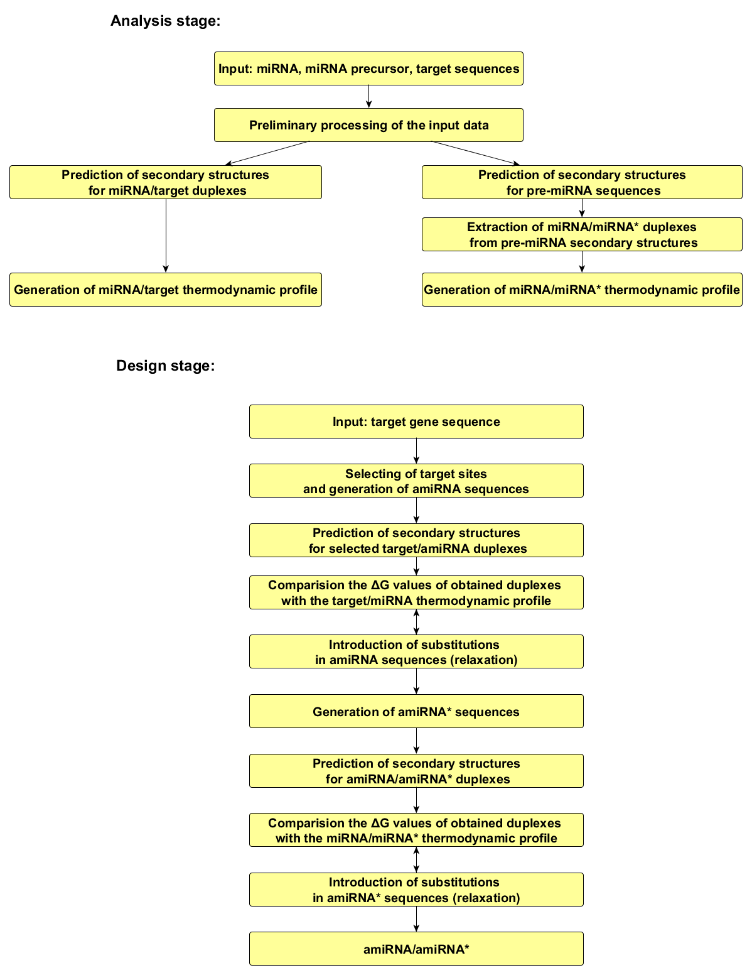

Fig 1. AmiDesigner workflow. The scheme presents the most important steps of the analysis performed in AmiRNA Designer. It is divided into the following stages: “Analysis stage” and “Design stage” which can be performed independently. As a result of the first stage the thermodynamic profiles are created. The second step allows to design amiRNA and amiRNA* sequences basing on the results obtained in the “Analysis stage”.

Analysis stage
157 sequences of 21 nt miRNA from A. thaliana were used to calculate nucleotide distribution. The obtained results showed that in almost 70% of all miRNAs the first nucleotide in the sequence is U and in over 40% the tenth is A (Fig 2.A). Moreover, in position 13 the C and in position 20 the G is underrepresented. Based on the obtained statistical data, we propose some sequence characteristics that can be considered in artificial miRNA design. AmiRNA Designer uses filter parameters for the target sites, where the specific residues correspond to the reverse complements of preferred residues in the miRNA sequence. The above observations for miRNAs from A. thaliana allowed us to set up the following filter parameters for potential target sites: U at position 12, A at position 21, not C at position 2 and not G at position 9. These parameters are optional and the user can decide which of them will be applied.
In the next step, two thermodynamic profiles were obtained: one for the miRNA/miRNA* and second for the miRNA/target duplex. These profiles show the distribution of the ΔG value assigned to each position of miRNA, graphically depicted as boxplots. Calculated thermodynamic profiles served as the reference for filtering of the newly designed amiRNA sequences in the next stage.
From the 570 pairs of miRNA and their targets available in the ASRP database, 210 unique 21 nt sequences were used to generate the miRNA/target thermodynamic profile (Fig 2. C). The analyzed set of miRNA/target interactions contained both validated and computationally predicted pairs of miRNA/targets for A. thaliana, where the computational prediction was based on the homology with experimentally validated miRNA/mRNA pairs for another plants. There are several distinctive features in this profile. The most significant seems to be the central region of miRNA, between residue 10 and 11, where the AGO cleavage occurs in the mRNA strand. In this region the thermodynamic profile shows the local minimum of the ΔG value which implies the strongest base pairing at the cleavage site. There are also two other local minima, associated with positions 3-4 and positions 16-17 of miRNA, respectively. Moreover, our miRNA/target thermodynamic profile for A. thaliana reveals a discrepancy between the “5’ half” and the “3’ half” of miRNA. In case of “5’ half” the median value is equal to -2.04 kcal/mol, whereas the corresponding value of the “3’ half” is -1.83 kcal/mol, what can suggest week analogy to the animal seed region, where about a 7 nt fragment from the miRNA 5’ end shows almost perfect pairing whereas the rest shows weak complementary (Lim et al., 2003).
For 157 miRNA precursor sequences, secondary structures were predicted, miRNA/miRNA* pairs with 10 flaking bases from both sides were extracted and the miRNA/miRNA* thermodynamic profile was created. The obtained profile of A. thaliana miRNA/miRNA* (Fig 2. B) shows higher free energy associated with the first position of miRNA than with the last position, which is consistent with previously described features of animal miRNA precursors (Khvorova et al., 2003, Krol et al., 2004). In the central region, the local maximum occurs, what is in contradiction with the miRNA/target thermodynamic profile. We also observed two local minima: the first in the “5’ half” of miRNA and the second one in the “3’ half”. These features, derived from the miRNA/miRNA* thermodynamic profile, were implemented in the design stage of amiRNA*.

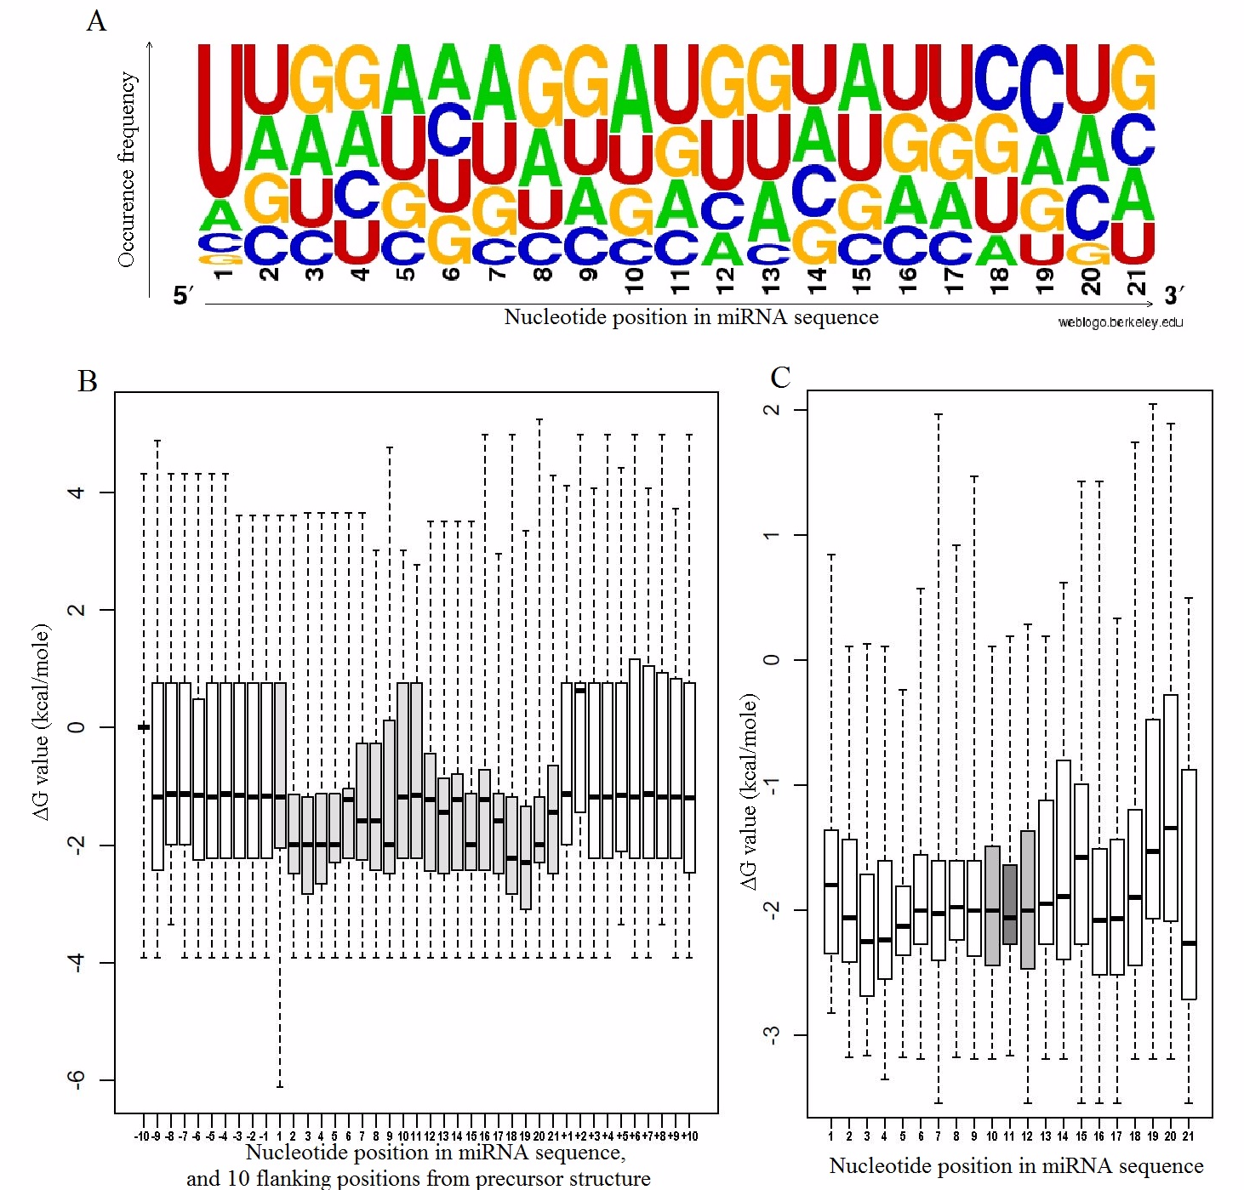

Fig 2. Analysis of Arabidopsis thaliana miRNA sequences. A). The statistical occurrence of nucleotides in specific miRNA positions for a set of 21 nt miRNAs from A. thaliana (analysis prepared with http://weblogo.berkeley.edu/). B), C). Thermodynamic profiles for A. thaliana generated by AmiRNA Designer. B). The thermodynamic profile of miRNA/miRNA* duplex. C). The thermodynamic profile of miRNA/target duplex. The bottom and the top of the box correspond to the lower and upper quartiles. Inside the box the median is located. Ends of the whiskers refer to the minimal and maximal values.

Design stage
In the first step of amiRNA design stage, the sequence of the target gene (mRNA) to be silenced was fragmented into 21 nucleotide-long (or 20 nt) parts with a shift of one nucleotide. These 21 nucleotide-long sequences are considered as potential target sites for amiRNA. Then, for each of the potential target site, reverse complementary sequence is generated, to obtain a primary amiRNA/target duplex. The number of generated amiRNA/target duplexes can be reduced by applying sequence filters obtained in the analysis stage. Usually, amiRNA candidates are designed to have U at position 1. To achieve this, the user can choose the filter for A at the position 21 of the target, or reduce potential targets sites to the length of 20 nt and add an A nucleotide at the end, that introduces U at the first position of amiRNA (U-force option). In principle, the program allows to set any nucleotide on a selected amiRNA position as forced or forbidden. Next, the secondary structure of amiRNA/target duplex is predicted to obtain free energy decomposition, and recalculated according to the rules for the profile generation. The results are compared to the thermodynamic profile of miRNA/target generated previously. There are mainly two prerequisites that have to be fulfilled for amiRNA sequence to be accepted. First, ΔG values at each position in a given amiRNA sequence have to fit in the range of the lower and upper quartile at corresponding positions in miRNA/target thermodynamic profile. The amiRNA sequences that do not satisfy this condition are immediately rejected. Next, it is checked whether the changes in the ΔG values at the individual positions in amiRNA show the same overall trend as the medians in miRNA/target thermodynamic profile. At this stage, if at some positions the ΔG is to low (the biding is too strong), relaxation can be applied by introducing GU base pairs. The substitutions are allowed in the amiRNA sequence and are the following: A →G and C → U, what results in GU and UG pairs in the amiRNA/target duplex, respectively. Both the number of the allowed GU pairs (default 3) and the minimal distance between them (default 5) are user-defined. When all necessary and permitted relaxations have been introduced, the thermodynamic profile of the modified amiRNA/target duplex is recalculated and compared with the reference miRNA/target profile. If the above mentioned prerequisites are fulfilled, then the modified amiRNA is accepted. In the next step, the amiRNA* sequence is designed. It is done similarly as in the case of amiRNA design. First, a reverse complementary sequence for amiRNA is created. Next, the thermodynamic profile for individual amiRNA/amiRNA* duplex is calculated and compared with the previously generated miRNA/miRNA* thermodynamic profile. The rules of the relaxations are the same as previously described and at this step only the amiRNA* sequence is modified whereas the amiRNA sequence is set as fixed. Finally, if the thermodynamic profile for the amiRNA/amiRNA* duplex fulfills all the defined rules, the amiRNA* sequence is accepted. The duplex amiRNA/amiRNA* is the final result of the design process.
The high complementarity to the target site makes amiRNA sequences almost unique. However, introducing substitutions (that results in GU and UG base pairs) in the amiRNA sequence requires checking whether such modified amiRNA is able to silence genes other than the gene of interest. Our Perl scripts search all designed amiRNA and amiRNA* sequences against the off-target genes. We defined the following rules for the amiRNA/target binding: only one mismatch could occur between the 3-9 nucleotide and only two non-consecutive mismatches are allowed between the 13-21 nucleotide of the miRNA sequence. As a result of the analysis, the user obtains the file that contains a list of artificial miRNA candidates that bind to the genes other than the target gene, together with their annotations (hypothetical off-targets).

Example
As an application of AmiRNA Designer we generated amiRNA candidates for two target genes: AGB1 (ID: AT4G34460, alias names: ATAGB1, ELK4, ERECTA-LIKE 4, GTP BINDING PROTEIN BETA 1), and Immutans (ID: AT4G22260, alias names: IM, IM1, IMMUTANS, PLASTID TERMINAL OXIDASE, PTOX). The analysis performed with psRNATarget (Dai and Zhao, 2011) software showed the lack of the natural miRNAs for these genes. This analysis ensured us that the set of miRNA sequences used to create the thermodynamic reference profile did not contain the miRNA directed for the studied sequences. The design procedure was performed with the following parameters: the U residue on the position 12 within target site and the U forced option. In the case of ABG1 target, AmiRNA Designer revealed 22 amiRNA/amiRNA* duplexes whereas in the case of Immutans 20 amiRNA/amiRNA* candidate duplexes were generated. Exemplary miRNA/miRNA* sequences are shown in Table1 (all designed sequences are presented in Table 1S and 2S). Analysis of the off-target effect showed that none of amiRNA* was complement to any of A. thaliana mRNA sequences. For AGB1 only one amiRNA had a potential off-target effect on hypothetical protein (gi:110740355, gb:ak230271). In the case of Immutans, there were at least 3 amiRNA/amiRNA* duplexes with no hypothetical off-target effect, however majority of amiRNA sequences were complementary to the hypothetical, putative or unknown proteins (all designed sequences are presented in Table 3S and 4S). A list of the potential off-targets and miRNA mismatch positions for a given target gene are presented to the user. For additional verification of our software, we applied psRNATarget server to find targets for our designed amiRNA sequences. Using default parameters, the server generated the list of potential targets for our amiRNA candidates but the originally launched target sequence had significantly better scores than the remaining genes.

Table 1. The sequences of amiRNA and amiRNA* designed using AmiRNA Designer, where the relaxation rules have been applied.
Substitutions introduced during the design stage in the amiRNA sequence are marked in red while those introduced in the amiRNA* sequence are marked in blue. Both sequences are presented in the 5’-3’ direction. The name of the amiRNA sequence consists of: the target gene alias name (e.g. Imm), start position of the amiRNA/target binding site and the list of substitutions inserted in the design stage separated by underscore.

CONCLUSIONS
AmiRNA-mediated gene silencing has emerged as an effective and promising technique and became one of the most important tools widely explored in genetic engineering. By using dedicated programs, amiRNA sequences to target genes of interest can be design, but there are still many problems concerning their efficiency and specificity that need to be solved.
We have demonstrated a novel, efficient approach for the semi-automated design of artificial microRNAs, which we have implemented as software AmiRNA Designer. The aim of the AmiRNA Designer is to design the amiRNA sequences to the target gene of interest that exhibit similar thermodynamic properties as the native ones, to increase the probability that the designed sequences will be processed such as those naturally occurring and will be target-specific. The thermodynamic properties of the native miRNA molecules are calculated based on the secondary structures of the input sequences. Based on the performed analysis the customized constraints are created for the design stage. The off-target silencing is verified using the algorithm implemented as Perl scripts that filters out the amiRNA candidates targeting of unwanted genes.

ACKNOWLEDGMENTS
This work was supported by grant from National Science Center, Poland [2012/05/B/ST6/03026].

REFERENCES
Axtell MJ, Westholm JO, and Lai EC. (2011) Vive la différence: biogenesis and evolution of microRNAs in plants and animals. Genome Biology, 12: 221.
Baby J, Vrundha N, and Chandy S. (2012) AmiRzyn: PERL Centered Artificial MicroRNA Designing Aid. International Research Journal of Biological Sciences, 1: 18–23.
Bartel DP. (2009) MicroRNAs: target recognition and regulatory functions. Cell, 136: 215–233.
Blazewicz J, Figlerowicz M, Kasprzak M, Nowacka M and Rybarczyk A. (2011) RNAPartial Degradation Problem: motivation, complexity, algorithm, Journal of Computational Biology, 18: 821-834.
Bologna NG, Schapire AL, Zhai J, Chorostecki U, Boisbouvier J, Meyers BC, and Palatnik JF. (2013) Multiple RNA recognition patterns during microRNA biogenesis in plants. Genome research, 23: 1675–1689.
Brodersen P, and Voinnet O. (2009) Revisiting the principles of microRNA target recognition and mode of action. Nature Reviews Molecular Cell Biology, 10: 141–148.
Carbonell A, Takeda A, Fahlgren N, Johnson SC, Cuperus JT and Carrington JC (2014) New generation of artificial microRNA and synthetic trans-acting small interfering RNA vectors for efficient gene silencing in Arabidopsis. Plant Physiol, 165: 15-29.
Carthew RW and Sontheimer EJ. (2009) Origins and Mechanisms of miRNAs and siRNAs. Cell, 136: 642-55.
Chau BL, and Lee KA. (2007) Function and anatomy of plant siRNA pools derived from hairpin transgenes. Plant methods, 3: 13.
Chekulaeva M, and Filipowicz W. (2009) Mechanisms of miRNA-mediated post-transcriptional regulation in animal cells. Current opinion in cell biology, 21: 452–460.
Dai X, and Zhao PX. (2011) psRNATarget: a plant small RNA target analysis server. Nucleic acids research, 39: W155–W159.
Dong Q, Schlueter SD, and Brendel V. (2004) PlantGDB, plant genome database and analysis tools. Nucleic acids research, 32: D354–D359.
Duvick J, Fu A, Muppirala U, Sabharwal M, Wilkerson MD, Lawrence CJ, Lushbough C, and Brendel V. (2008) PlantGDB: a resource for comparative plant genomics. Nucleic acids research, 36: D959–D965.
Eamens AL, Smith NA, Curtin SJ, Wang MB, and Waterhouse PM. (2009) The Arabidopsis thaliana double-stranded RNA binding protein DRB1 directs guide strand selection from microRNA duplexes. RNA, 15: 2219–2235.
Friedman RC, Farh KK-H, Burge CB, and Bartel DP. (2009) Most mammalian mRNAs are conserved targets of microRNAs. Genome research, 19: 92–105.
Griffiths-Jones S, Saini HK, van Dongen S, and Enright AJ. (2008) miRBase: tools for microRNA genomics. Nucleic acids research, 36: D154–D158.
Gustafson AM, Allen E, Givan S, Smith D, Carrington JC, and Kasschau KD. (2005) ASRP: the Arabidopsis small RNA project database. Nucleic acids research, 33: D637–D640.
Han J, Lee Y, Yeom K-H, Nam J-W, Heo I, Rhee J-K, Sohn SY, Cho Y, Zhang B-T, and Kim VN. (2006) Molecular basis for the recognition of primary microRNAs by the Drosha-DGCR8 complex. Cell, 125: 887–901.
Khvorova A, Reynolds A, and Jayasena SD. (2003) Functional siRNAs and miRNAs exhibit strand bias. Cell, 115: 209–216.
Kim JY, Kwak KJ, Jung HJ, Lee HJ, and Kang H. (2010) MicroRNA402 affects seed germination of Arabidopsis thaliana under stress conditions via targeting DEMETER-LIKE Protein3 mRNA. Plant and cell physiology, 51: 1079–1083.
Kim VN. (2005a) MicroRNA biogenesis: coordinated cropping and dicing. Nature Reviews Molecular Cell Biology, 6: 376–385.
Kim VN. (2005b) Small RNAs: classification, biogenesis, and function. Mol Cells, 19: 1–15.
Krol J, Sobczak K, Wilczynska U, Drath M, Jasinska A, Kaczynska D, and Krzyzosiak WJ. (2004) Structural features of microRNA (miRNA) precursors and their relevance to miRNA biogenesis and small interfering RNA/short hairpin RNA design. Journal of Biological Chemistry, 279: 42230.
Kurihara Y, and Watanabe Y. (2004) Arabidopsis micro-RNA biogenesis through Dicer-like 1 protein functions. Proceedings of the National Academy of Sciences of the United States of America, 101: 12753.
Laganà A, Acunzo M, Romano G, Pulvirenti A, Veneziano D, Cascione L, Giugno R, Gasparini P, Shasha D, Ferro A, and others. (2014) miR-Synth: a computational resource for the design of multi-site multi-target synthetic miRNAs. Nucleic acids research, gku202.
Lee Y, Kim M, Han J, Yeom KH, Lee S, Baek SH, and Kim VN. (2004) MicroRNA genes are transcribed by RNA polymerase II. The EMBO journal, 23: 4051–4060.
Li J-F, Chung HS, Niu Y, Bush J, McCormack M, and Sheen J. (2013) Comprehensive protein-based artificial microRNA screens for effective gene silencing in plants. The Plant Cell Online, 25: 1507–1522.
Lim LP, Lau NC, Weinstein EG, Abdelhakim A, Yekta S, Rhoades MW, Burge CB, and Bartel DP. (2003) The microRNAs of Caenorhabditis elegans. Genes \& development, 17: 991–1008.
Mallory AC, and Vaucheret H. (2004) MicroRNAs: something important between the genes. Current opinion in plant biology, 7: 120–125.
Markham NR, and Zuker M. (2008) UNAFold. Bioinformatics (pp. 3–31).
Meola N, Gennarino VA, and Banfi S. (2009) microRNAs and genetic diseases. Pathogenetics, 2: 7.
Nowacka M, Jackowiak P, Rybarczyk A, Magacz T, Strozycki PM, Barciszewski J, and Figlerowicz M. (2011) 2D-PAGE as an effective method of RNA degradome analysis. Mol. Biol. Rep., 39: 139-146.
Obernosterer G, Meister G, Poy MN, and Kuras A. (2006) The impact of small RNAs. EMBO reports, 8: 23–27.
Ossowski S, Schwab R, and Weigel D. (2008) Gene silencing in plants using artificial microRNAs and other small RNAs. The Plant Journal, 53: 674–690.
Petri S, and Meister G. (2013) siRNA design principles and off-target effects. Target Identification and Validation in Drug Discovery (pp. 59–71).
Schwab R, Ossowski S, Riester M, Warthmann N, and Weigel D. (2006) Highly specific gene silencing by artificial microRNAs in Arabidopsis. The Plant Cell Online, 18: 1121–1133.
Sunkar Ramanjulu, Li Y-F, and Jagadeeswaran G. (2012) Functions of microRNAs in plant stress responses. Trends in plant science, 17: 196–203.
Sunkar R., and Zhu JK. (2004) Novel and stress-regulated microRNAs and other small RNAs from Arabidopsis. The Plant Cell Online, 16: 2001–2019.
Szostak N, Royo F, Rybarczyk A, Szachniuk M, Blazewicz J, del Sol A, Falcon-Perez JM. (2014) Sorting signal targeting mRNA into hepatic extracellular vesicles. RNA Biol, 11:836–844.
Valencia-Sanchez MA, Liu J, Hannon GJ, and Parker R. (2006) Control of translation and mRNA degradation by miRNAs and siRNAs. Genes \& development, 20: 515.
Walter AE, Turner DH, Kim J, Lyttle MH, Müller P, Mathews DH, and Zuker M. (1994) Coaxial stacking of helixes enhances binding of oligoribonucleotides and improves predictions of RNA folding. Proceedings of the National Academy of Sciences, 91: 9218–9222.
Xie Z, Allen E, Fahlgren N, Calamar A, Givan SA, and Carrington JC. (2005) Expression of Arabidopsis MIRNA genes. Plant Physiology, 138: 2145–2154.
Yu S and Pilot G. (2014) Testing the efficiency of plant artificial microRNAs by transient expression in Nicotiana benthamiana reveals additional action at the translational level. Front Plant Sci., 5: 622.

Supplementary Materials:
Supplementary Materials.pdf (plik jest pod adresem: http://www.cs.put.poznan.pl/arybarczyk/SupplementaryMaterials.pdf)

